PROJECT 2: SPEECH RESTORATION

# Introduction

Speech restoration and denoising are essential approaches in audio processing. The project's aim is to refine a mixed noise audio recording and make the speech clearer. The challenges were a disruptive fire alarm, a ringtone, and persistent background AC noise. The MATLAB code applies basic yet resilient solutions. It uses band stop filters for the fire alarm, removes the unwanted ringtone using a file which was provided, and improves the overall audio through lowering background AC noise. The project employs fundamental audio processing techniques to systematically address each source of noise and enhance the overall clarity of the speech signal.

# Implementation Steps

The MATLAB implementation aims to improve the quality of an audio recording that contains various sources of noise, including a fire alarm, a ringtone, and AC noise. The process begins by loading the mixed audio file and extracting the signal, setting the sampling frequency to 8000 Hz. Subsequently, band stop filters are applied to eliminate fire alarm frequencies. The ringtone is removed by subtracting a zero-padded version from the signal. AC noise is addressed by loading and resampling a separate AC noise file, and the resulting noise is subtracted from the audio. A specific segment of the signal is then amplified. The amplified audio is both played and saved as a WAV file.

1. **Load and Visualize Original Signal:** Import the mixed audio file, extract the signal, and visualize the original audio in both the time domain and spectrogram for initial assessment.

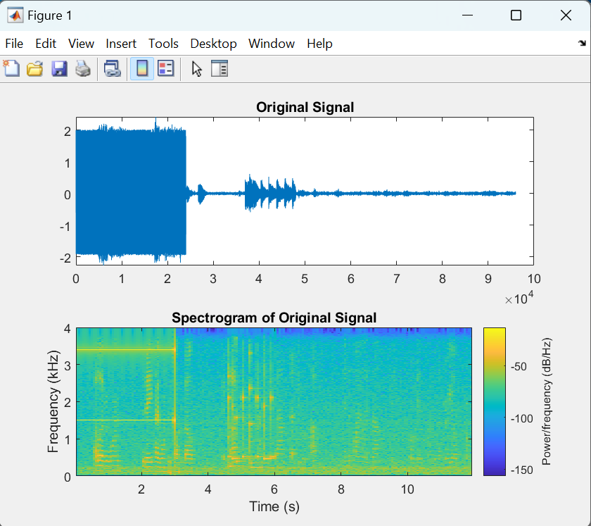

The fire alarm is present in the audio recording from the beginning until nearly 2.5 seconds, and the ringtone occurs between 4 and 6 seconds. There are 2 bands shown in the fire alarm part which needs to be removed.

1. **Remove Fire Alarm Frequencies:** Utilize band-stop filters to selectively eliminate fire alarm frequencies, showcasing the impact on both the time and frequency domains.

The two frequency bands at 1.5K Hz and almost 3.3K Hz were removed through the MATLAB function bandstop().

1. **Remove Ringtone:** Employ a subtraction approach using a zero-padded version of the ringtone file to effectively eliminate its influence on the audio signal.

The ringtone file was synchronized to the portion corresponding to the presence of the ringtone noise (from 4 to 6 seconds) by employing a zero-padded version of the mixed signal. This synchronized ringtone was subtracted from the signal cleared of the fire alarm.

1. **Remove AC Noise:** Import a recording of AC noise in the same room where the recording was taken, resample it, adjust it to the length of the main signal and finally subtract it from the signal. Assess the noise reduction by examining the refined audio in both the time and frequency domains.

The speech signal is now more audible and clearer, as the background AC noise has been successfully eliminated.

1. **Amplify a Specific Section:** Implement an amplification method on a targeted portion of the signal by multiplying with a constant and show the result on time and frequency domains.

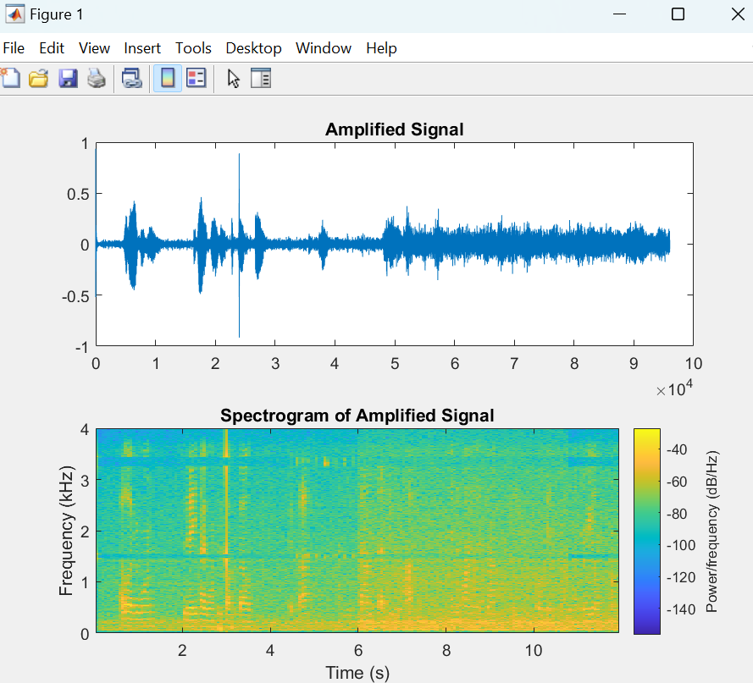

The end section from 6 seconds to 12 seconds is amplified by 1.5 to be more audible.

1. **Play and Save Amplified Signal:** Execute the playback of the amplified audio to audibly experience the improvements. Simultaneously, save the enhanced audio as a WAV file in the MATLAB folder for future reference. The function audiowrite() is used to save the file.

# Conclusion & Result

The figure 6 shows the difference between the initial mixed audio signal and the final clean version of the signal. There’s a major change in the clean version compared to the mixed noise.

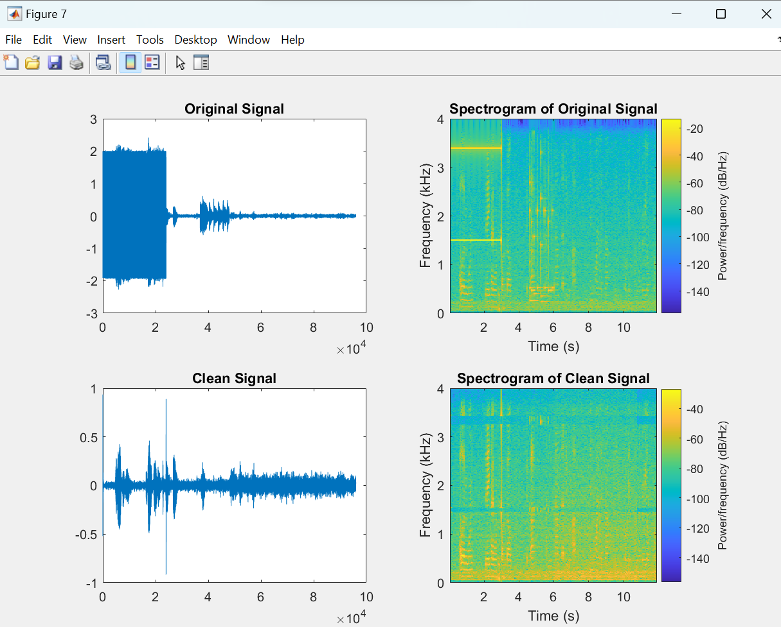

In conclusion, the audio processing techniques utilized have greatly enhanced the quality of the speech signal. The removal of fire alarm frequencies, removal of the ringtone, as well as the reduction of background AC noise, all contribute to a significantly better audio output. The amplified portion has improved the signal; however, experimenting with various methods in MATLAB for additional refinement might refine the results and increase the clarity. Incorporating a speech2text function for in-depth analysis of the speech content would also be beneficial. Future versions might benefit from experimenting with other audio processing approaches and using advanced MATLAB capabilities to obtain a clearer and more accurate understanding of the amplified voice input.